Pathology of acid-alkaline balance and laboratory diagnostics
Acid-alkaline balance means a set of physico-chemical (buffer systems) and physiological (respiratory, kidney, digestive) mechanisms that ensure the relative stability of the body's fluid environment. The normal functioning of the body depends on the regulation of the acid-alkaline balance. The pH of the extracellular fluid is determined in the normal physiological range between 7.35 and 7.45. During metabolic processes, volatile and non-volatile metabolic acids are formed, which are removed from the body through buffer systems.
The stability of the acid-alkaline balance is a prerequisite for ensuring normal metabolism and activity of enzyme systems. This change of balance towards acidity is called acidosis, and its change towards alkalinity is called alkalosis. Normal blood pH is 7.35-7.45. A drop in blood pH below 7.35 is considered acidosis, and an increase above 7.45 is considered alkalosis. The purpose of the bicarbonate, phosphate, protein, hemoglobin buffer systems involved in the regulation of the acid-alkaline balance is to regulate the hydrogen ion balance in both the intracellular and extracellular fluid environment of the body. The regulation of hydrogen ion balance is one of the main components of ion homeostasis in the body. Buffer systems involved in the regulation of the hydrogen ion balance act in less than a second. The activity of buffer systems consists in removing hydrogen ions from the body or increasing their concentration in the body. As we know, the bicarbonate buffer system ensures the stability of the pH of extracellular fluids. The bicarbonate buffer system is 20 times more powerful than dissolved CO2. The phosphate buffer system maintains the pH stability of the renal tubular fluid and intracellular fluids. The protein buffer system is also involved in maintaining the pH stability of the intracellular fluid. The hemoglobin buffer system transports oxygen and carbon dioxide and regulates the acid-base balance.
Physiological mechanisms also have a great role in ensuring the stability of acid-alkaline balance. For example, the external respiratory system ensures the stability of the concentration of CO2 in the liquid environment of the body and has an effect within a few minutes. An increase in the partial pressure of carbon dioxide (pCO2) results in stimulation of the respiratory center. This leads to an increase in ventilation, the removal of excess CO2 from the body, and a decrease in the level of pCO2 in the extracellular environment.
The kidneys belong to the next system involved in maintaining the stability of the acid-alkaline balance. Kidney activity is observed for hours and days. At this time, excretion of H+ ions from renal tubules, reabsorption of filtered HCO3 ions and generation of new HCO3 ions occur. As we know, this is done due to acidogenesis and ammonogenesis processes. Thus, buffer systems use phosphate and ammonia to reduce the concentration of H+ ions. In chronic acidosis, the main mechanism that ensures the excretion of acid is based on the release of NH4-ammonium ions. Let's note the role of electrolytes in the regulation of acid-alkaline balance.
Plasma levels of K+ ions influence renal excretion of H+ ions and vice versa. During hypokalemia, secretion of H+ ions and reabsorption of HCO3− ions is observed. When plasma K+ levels fall, K+ moves from the intracellular to the extracellular domain. In contrast, H+ ions move from the extracellular space to the intracellular space. A similar process occurs in the distal tubules of the kidney, as K+ is actively reabsorbed, H+ is secreted, or vice versa.
Thus, during acidosis, the elimination of H+ ions increases and the elimination of K+ ions decreases, resulting in an increase in the level of potassium in the plasma. During alkalosis, H+ elimination decreases and K+ elimination increases.
Another mechanism used by the kidneys to regulate the concentration of HCO3− ions is chloride-bicarbonate anion exchange, which is dependent on Na+ reabsorption. Normally, Cl- ions are reabsorbed along with Na+ throughout the renal tubule.
During vomiting and when the total volume of fluid in the body decreases due to depletion of chlorine ions, the kidney replaces Cl− anion with HCO3− and the reabsorption of HCO3− ions increases. An increase in pH in hypochloremic alkalosis,
A decrease in the level of Cl- is observed, as a result of which HCO3− reabsorption increases. In hyperchloremic acidosis, HCO3− reabsorption is reduced due to increased Cl− levels.
According to the mechanism of development, 2 types of both acidosis and alkalosis are identified, gaseous and non-gaseous. Certain indicators are used to determine different types of these disorders. Key indicators:
* blood pH - norm 7.35-7.45;
* pCO2 in blood – norm 35.0-45.0 mm Hg;
* pO2 in blood - norm 80-100 mm Hg;
* O2 saturation 95-100%
* Na+ -- norm 136.0-146.0 mmol/l.;
* K+ - norm 3.4-4.5 mmol/l,;
* Ca++ - norm 1.15-1.29 mmol/l,;
* SB (Standard Bicarbonate – standard bicarbonate of blood plasma):
HCO3˘ – norm 22-26 mmol/l;
* BB (Buffer Base) - norm 40-48 mmol/l. This indicator is the sum of standard bicarbonates and other anion reserves (protein buffer) in plasma;
* BE (Base Excess). It is the difference between the normal indicator of BB and the detected indicator - the norm is ±2.5 mmol/l.
Due to the loss of HCO3 ion during metabolic acidosis, it is observed to decrease in plasma and increase non-volatile acid products. Accordingly, a decrease in plasma pH is noted. At this time, pulmonary ventilation and the elimination of volatile CO2 gas and the reabsorption of HCO3 ions from the kidneys take place as a compensator.
Metabolic acidosis can develop for the following reasons (Figure 1):
•Metabolic acidosis is observed during the increase in the formation of acidic products. During pathologies accompanied by metabolic disorders, the formation of acidic products in the body increases. For example, in diabetes mellitus, the use of glucose by cells is impaired due to a relative or absolute deficiency of the hormone insulin. At this time, the body does not get the necessary energy from glucose, but from the oxidation of fats as an alternative way. The breakdown of fats in the liver is accompanied by the formation of large amounts of ketone acids, which causes acidosis;
• Metabolic acidosis can also occur in the body during kidney dysfunction. In kidney diseases, there is a violation of the excretory function of the kidneys. At this time, the excretion of excess acids in the body and the reabsorption of alkalies are disturbed. This can cause acidosis;
• Metabolic acidosis can occur in pathologies of the gastrointestinal system. For example, diarrhea of various origins and the loss of large amounts of alkali with digestive juices during surgical interventions in the intestines can be an example of this. In the hyperchloremic acidosis that occurs at this time, the concentration of Cl− ions increases, HCO3− reabsorption decreases, as a result, a decrease in plasma pH is observed;
• During poisoning with various poisons and toxic substances, the breakdown of these substances in the body can cause acidosis.
Thus, during acidosis, the elimination of H+ ions increases, the elimination of K+ ions decreases, as a result, the concentration of K+ ions in the plasma increases.
Clinical manifestations during metabolic acidosis are reflected in figure 1.

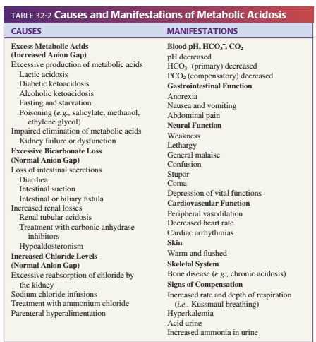

• Metabolic alkalosis is characterized by an increase in plasma HCO3− ions and pH. At this time, as a compensator, there is a decrease in lung ventilation, the elimination of volatile CO2 gas, and an increase in the excretion of HCO3- ions by the kidneys.
Metabolic alkalosis can develop for the following reasons (Figure 2).
• during the loss of a large amount of acidic stomach contents (hypochloremia). For example, this can be observed during incessant vomiting, aspiration of acidic stomach contents through special probes. At this time, the body loses Cl− ions. Accordingly, the kidney replaces Cl− anion with HCO3− ions and the reabsorption of HCO3− ions increases. This causes an increase in blood pH during hypochloremic alkalosis;
• diuretiklərin uzun müddətli istifadəsi;
• increased excretion of hydrogen ions through the kidneys. For example, hypernatremia and hypokalemia occur during hypersecretion of mineralocorticoids. Hypersecretion of aldosterone can be observed in the pathology of the adrenal gland and other organs (for example, heart failure). During alkalosis, the elimination of H+ ions decreases and the excretion of K+ ions increases, as a result, the concentration of K+ ions in the plasma decreases.
Clinical manifestations during metabolic alkalosis are reflected in figure 1.
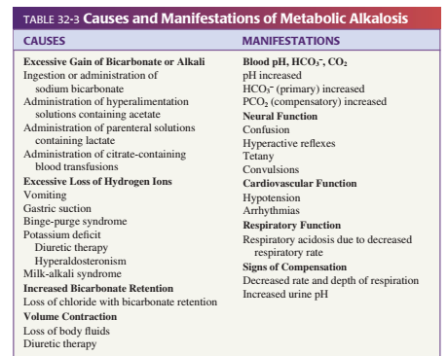

During respiratory acidosis or hypercapnia, there is an increase in blood PCO2 and a decrease in plasma pH. This is caused by a decrease in alveolar ventilation. Compensatory mechanisms include retention of HCO3 ion in the body, excess formation, and increased elimination of H+ by the kidneys. Respiratory acidosis develops as a result of the accumulation of a large amount of carbon dioxide in the blood. Carbon dioxide combines with water to form carbonic acid. This causes the pH of the blood to drop. Gaseous acidosis occurs during respiratory pathologies (for example, bronchial asthma, etc.), damage to the respiratory muscles and the nerves that innervate them (lateral amyotrophic sclerosis, etc.) that lead to a decrease in the ventilation volume of the lungs, etc. may develop in some cases.
The causes of respiratory acidosis are given in figure 3.
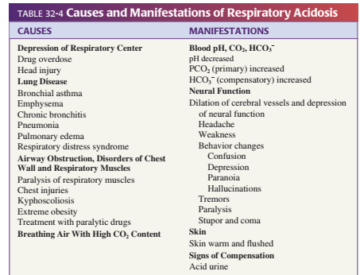

Clinical manifestations during respiratory acidosis are reflected in figure 2.
During respiratory alkalosis or hypocapnia, blood PCO2 decreases and plasma pH increases. This is caused by increased alveolar ventilation. Compensatory mechanisms include increased elimination of HCO3 ions by the kidneys and retention of H+ ions in the body.
The causes of respiratory alkalosis are given in figure 4.
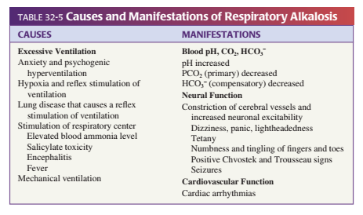

Thus, with respiratory acidosis, metabolic alkalosis; respiratory alkalosis is compensated by metabolic acidosis. Metabolic acidosis, with respiratory alkalosis; metabolic alkalosis is compensated by respiratory acidosis.
The study of acid-alkaline balance plays an important role in diagnosing the patient, determining the etiology and severity of the disease, and treating the patient. One of the goals of studying the gas composition of the blood is to evaluate the function of the respiratory system. The function of the respiratory system means ventilation and oxygenation of the blood. Partial pressures of oxygen (PaO2) and carbon dioxide (PaCO2), oxygen saturation (SaO2), blood pH and bicarbonate concentration in arterial blood are studied in order to assess acid-alkaline balance, respiratory system and various metabolic diseases. Indications for arterial blood gas analysis can be summarized as follows:
• Diagnosis of metabolic and respiratory acidosis and alkalosis
• Determination of the type of respiratory failure
• Instruction for oxygen therapy
• Study of sudden and unexplained dyspnea
If measurement of oxygen partial pressure is not required, venous blood gas analysis is usually sufficient to assess acid-base balance. The pH of venous blood is usually 0.03-0.04 units lower than the pH of arterial blood. The partial pressure of carbon dioxide (pCO2) in venous blood is 7-8 mm Hg, and the concentration of HCO3 is 2 mev/l higher than in arterial blood.
*If the partial pressure of oxygen in the arterial blood is normally 80-100 mm cv.st. if taken:
PaO2 60-79 mm Hg mild hypoxemia if between;
PaO2 40-59 mm Hg moderate hypoxemia if between;
PaO2 40 mm cv.st. if it is low, it is called severe hypoxemia.
*Standard bicarbonate: It is the value of bicarbonate in blood under standard conditions (temperature -37°C and PCO2-40 mm Hg). Normally it is 22-26 mev/l.

*Actual Bicarbonates: The actual bicarbonate value in the blood. Normally 22-26 mev/L.

HCO3 >26 = Alkalosis

HCO3 <22 = Acidosis

If the standard bicarbonate is less than the actual bicarbonate, respiratory acidosis develops, and if the standard bicarbonate is greater than the actual bicarbonate, respiratory alkalosis develops. If the standard bicarbonate is equal to the actual bicarbonate, but less than the norm, decompensated metabolic acidosis develops, and if the standard bicarbonate is equal to the actual bicarbonate, but more than the norm, decompensated metabolic alkalosis develops.

*BE (Base Excess): temperature 37ºC and partial pressure of carbon dioxide (pCO2) 40 mm cv.st. which is the amount of acid or base required to raise the pH of fully oxygenated blood to 7.40. The normal value of BE is ±2.5 mmol/l.

BE < 2.5 =metabolic acidosis

BE >2.5 =metabolic alkalosis occurs.

*Alveolar-arterial oxygen gradient: It is the difference between the partial pressure of oxygen in alveolar air and the partial pressure of oxygen in arterial blood (pO2). This gives an overview of the diffusion of gases. Normally, the alveolar-arterial oxygen gradient is 5 mm.cv.st. is equal to However, due to age, after the age of 20, every 10 years, 4 mm.cv.st. growth is observed.

* Measurement of arterial blood pH

* Determination of acidosis and alkalosis: pH < 7.35 - acidosis; pH >7.45 is considered as alkalosis. Determination of pH indicates that the patient has acidosis or alkalosis, but cannot determine their type. pH is the only parameter that determines compensated acidosis or alkalosis. If the normal pH is in the range of 7.35-7.45, pH<7.35 is called decompensated acidosis, and if pH>7.45 it is called decompensated alkalosis.

* To determine whether the problem is caused by the pathology of the metabolic or respiratory system

* Electrolytes in the serum are Na+, K+, H+, Cl−, etc. in the assessment of acid-alkaline imbalance. is appointed. Other anions (e.g., sulfates, phosphates, proteins) and cations (e.g., calcium, magnesium, proteins) are not routinely measured, but can be estimated indirectly because (to maintain neutrality) the sum of the cations must equal the sum of the anions. In serum, Na+ and K+ ions make up 95% of the cations, and Cl- and HCO3 ions make up about 85% of the anions.

During metabolic acidosis, if the plasma Na concentration does not change, the concentration of anions must increase to maintain neutrality.

*They use the study of anion difference in the diagnosis of acid-alkaline balance disorders. Anion gap refers to the difference between anions and cations. Plasma anion difference (Na+ + K+)--(CI- + HCI3)—(142+4)-(106+24)=8-16 mev/l, but in shortened form Na-HCO3-CI=8-16 mev/l l is calculated by this formula. If the anion difference is greater than the norm, metabolic acidosis is diagnosed, that is, the concentration of anions is high. If CI- ions in the plasma increase in proportion to the decrease of HCO3- ions, the anion gap will remain normal, this is called hyperchloremic metabolic acidosis. If metabolic acidosis is caused by an increase in non-volatile acids (eg: lactate, ketonic acid, etc.), the plasma anion gap will increase. Because the decrease of HCO3- ions was not proportional to the increase of CI- ions. If the decrease of HCO3- ions in the plasma is not accompanied by an increase of CI- ions, the level of anions increases, which results in an increase in the anion gap (figura 5)
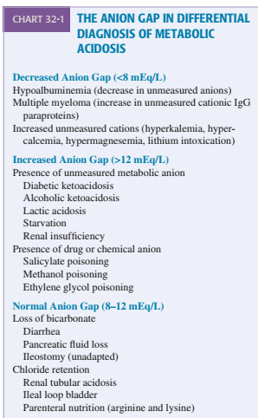
Treatment-based blood gas evaluation reveals simple acid-base imbalance if compensation is achieved, but mixed acid-base imbalance if expected compensation is not achieved.
In general, a violation of the acid-alkaline balance indicates the development of any pathological process in the body. The study of gas content of blood, as a rule, is purposeful in various pathologies of respiration and metabolism. The results of repeated analyzes allow monitoring the dynamics of the disease and evaluating the effectiveness of the prescribed therapy.
In modern times, blood sampling for the study of acid-alkaline balance is carried out using a PICO sampler, which provides high analytical quality.
This sampler is specially designed for blood sampling.
It contains a unique electrolyte balanced dry heparin that prevents thrombus formation and improves measurement accuracy. PICO50: a self-filled syringe with 2 ml of blood.

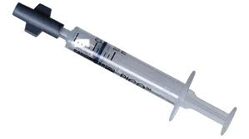

Radiometr Medical ApS, Made by Denmark.

The study of indicators of acid-base balance is also carried out in the ABL800FLEX blood gas analyzer.
The next device used to measure the osmotic pressure in body fluids is the OSMO STATION OM-6060 manufactured by ARKRAY Factory in Japan.

Pathology of water-electrolyte exchange and laboratory diagnostics
65% of the adult human body is composed of water. Water and electrolytes contained in the fluid environment of the body are distributed between the intercellular and extracellular (ICF and ECF) spaces. Two-thirds of the fluid in the body is intracellular (40-45%), one-third is extracellular (16% of body weight, blood plasma 5% and lymph 2%), and the rest (1-3%) is transcellular fluid (cerebrospinal and intraocular fluids, abdominal cavity, pleura, pericardium, joint cavities and gastrointestinal tract fluids). Water exchange in the body is inextricably linked with the exchange of electrolytes. Potassium, calcium, phosphorus and magnesium have high concentrations in the intracellular area, while sodium, chlorine and bicarbonate have high concentrations in the extracellular area. Differences in the electrolyte composition of blood plasma and tissue fluid ensure that proteins pass through the capillary wall less. The regulation of water-electrolyte exchange in a healthy person allows to maintain normal limits of fluid and electrolytes in the body. As we know, aldosterone, antidiuretic hormone (vasopressin), atrial natriuretic hormone (atriopeptide) and adrenaline play a role in keeping the amount of water in the body and its distribution between tissues stable (picture 1).
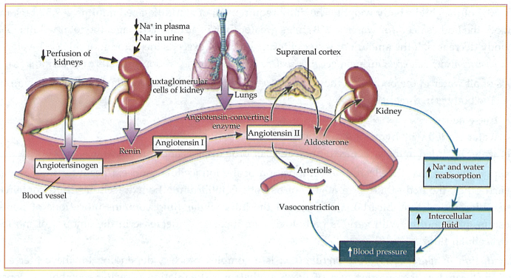
Figure 1. Regulation of water in the body.
How much water and electrolytes enter and leave the body is equally important for the normal functioning of all organs and systems. This ratio should be constant. If a person consumes 2 liters of fluid per day in the form of food and drink, then on average 1.5 liters of fluid per day will be excreted in the urine. The rest of the fluid is excreted through the intestines and lungs. Against the background of various diseases, the stability of this system is disturbed. At this time, either dehydration (dehydration) or water retention in the body (hyperhydration) occurs.
Dehydration is characterized by a negative water balance. Dehydration of the body can occur for several reasons. For example. low intake of water in the body, high water loss, violation of regulatory mechanisms of water-electrolyte exchange, etc. During dehydration, the loss of extracellular fluid and sodium ions is first observed. In more severe cases, intracellular fluid and potassium ions are lost (Figure 2).

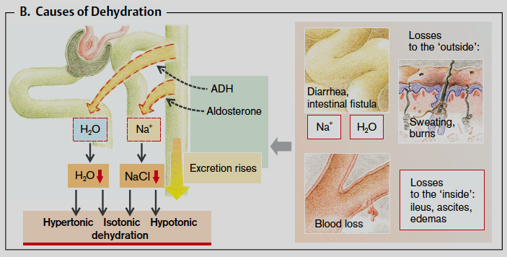

Figure 2. Causes of dehydration

Hyperhydration is characterized by a positive water balance and develops for several reasons. For example, excessive intake of water in the body, violation of water excretion through the kidneys, violation of regulatory mechanisms of water-electrolyte exchange (Figure 3).
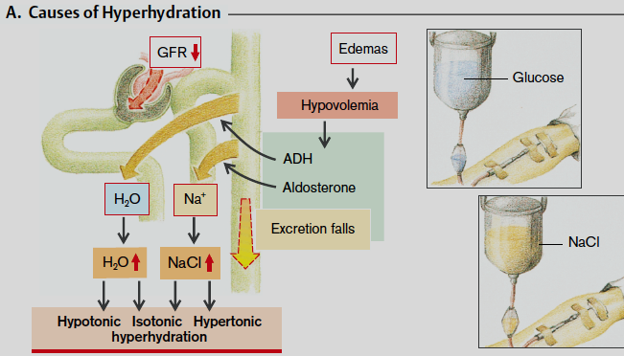

Figure 3. Causes of hyperhydration

Violation of the water-salt balance in the body occurs for various reasons.
For example:
Imbalanced diet (intake of excess carbohydrate foods)
Wrong liquid diet
Alcohol abuse
Intense physical activity
Adynamia
Cardiovascular diseases
Diarrhea and vomiting
Endocrine pathologies
Hyperthermia, etc.
Kidney and liver diseases
Metabolic disorders (Diabetes, etc.)
Excessive use of diuretics
Pregnancy toxicoses
Symptoms of dehydration:
Plaque on the surface of the tongue
Bad breath from the mouth
Dry skin
Acceleration of breathing
Nausea
Pain in joints and muscles
Tachycardia
Weight loss
Symptoms of hyperhydration:
Weakness
Vomiting
Edema
Don't convulse
Arrhythmia
Loss of consciousness
The volume of liquid in the body and the concentration of salts are studied using the laboratory examination of venous blood. These analyzes allow to assess the general state of the body. The study determines the concentration of potassium, sodium and chlorine in the blood, which are involved in metabolic processes, heart activity, transmission of nerve impulses and muscle contraction.
In order to determine the violation of the water-electrolyte balance in the body, it is necessary to consult a doctor first. Then, a clinical and laboratory-instrumental examination is carried out by the appointment of a doctor.
Thus, kidney diseases accompanied by an increase in urine output lead to dehydration, and kidney diseases accompanied by a violation of the filtration process lead to hyperhydration. One of the common causes of chronic kidney failure is arterial hypertension (fluid retention) and diabetes (fluid loss). At this time, the biochemical analysis of blood and the examination of urine include the level of urea, creatinine, protein, glucose, pH, as well as electrolytes: potassium, sodium, chlorine, etc. study of concentration and study of glomerular filtration rate, etc. belongs to. Ultrasound examination of organs of the excretory system is carried out and structural pathology in the organs is studied.
During dehydration, blood clotting, disruption of activity of factors involved in blood coagulation cascade are investigated.
In pathologies of the gastrointestinal system accompanied by profuse repeated vomiting and diarrhea, water balance is disturbed and dehydration occurs due to excess fluid loss. If the doctor suspects an intestinal infection, to detect the causative agent, a serological examination of the blood, the mass of feces and vomit, etc. bacteriological research is being conducted. Some congenital diseases of the gastrointestinal tract in children, for example, pilostenosis, often cause dehydration and a violation of the water-electrolyte balance of the body.
As we know, in pathologies of the endocrine system, an increase in the concentration of antidiuretic hormone causes fluid retention in the body, a decrease in the concentration of antidiuretic hormone (diabetes insipidus) and an increase in the secretion of atrial natriuretic hormone cause fluid loss in the body. In addition, aldosterone has a great role in maintaining electrolyte balance in the body.
Glucose is an osmotically active substance that can attract fluid. An excess amount of glucose in the blood, for example, in diabetes, glucose is excreted from the body together with liquid, leading to the development of dehydration.
Fluid retention in the body against the background of various diseases causes the formation of edema. One of the most common forms of hyperhydration is edema. Edema is a typical pathological process accompanied by accumulation of fluid in interstitial areas. As we know, several factors are involved in the mechanism of edema formation. For example, hydrostatic pressure of intracapillary and interstitial fluid, colloid-osmotic pressure of blood plasma and tissue fluid, permeability of the capillary wall and violation of lymphatic circulation can be shown.
.

According to its pathogenesis, it is inflammatory, allergic and toxic, according to its origin, it is cardiac, renal, liver, etc. there are edemas.

It refers to examination methods during edema:
* to determine local characteristics of edema or signs of systemic diseases by physical examination
* to determine the period of existence of edema
* to investigate the presence of pain in the area of edema
* pay attention to the color of the skin in the area of edema
* to conduct a doppler ultrasound examination of the lower extremities
* to perform computer tomography of organs
*Biochemical and general analysis of blood
*general analysis of urine
Applies to instrumental studies:
*electrocardiogram (ECG)
* echocardiography
*ultrasound examination
* X-ray of organs located in the chest, etc.
In order to effectively eliminate edema, it is necessary to clarify what disease it is caused by. Edema is not an independent disease, but a symptom. Using modern equipment and relying on diagnostics helps to determine the cause of the pathology. The obtained information allows the doctor to choose the most suitable treatment.

